
San Francisco Bay University

CS483L - Artificial Intelligence & Machine Learning Lab
Lab 8 Pandas-III

Objectives:
In this week’s lab, students will go ahead focusing on Pandas library function programming for excel file processing. And students can work on hands-on practice through example programs

Introduction:
Pandas is a software library written in the Python programming language for data manipulation and analysis. The Pandas module is a high performance, highly efficient and high level data analysis library. It is mainly used for AI data analysis in form of dataframes. At its core, it is very much like operating a headless version of a spreadsheet, like Excel.

Pandas allows importing data of various file formats such as csv, excel etc. It provides various data manipulation operations such as groupby, join, merge, melt, concatenation as well as data cleaning features such as filling, replacing or imputing null values.

Learning Resources:
- Cloud Python compiler google colab
- Lecture textbook & lab textbook at safari
- Lecture & lab manual

The Laboratory Procedure:
- Different Ways of Creating DataFrame
- Upload 2 files "weather_data.csv"& "weather_data.xlsx" to your google drive "My Drive/Colab Notebooks/"
- Mount google colab to your drive

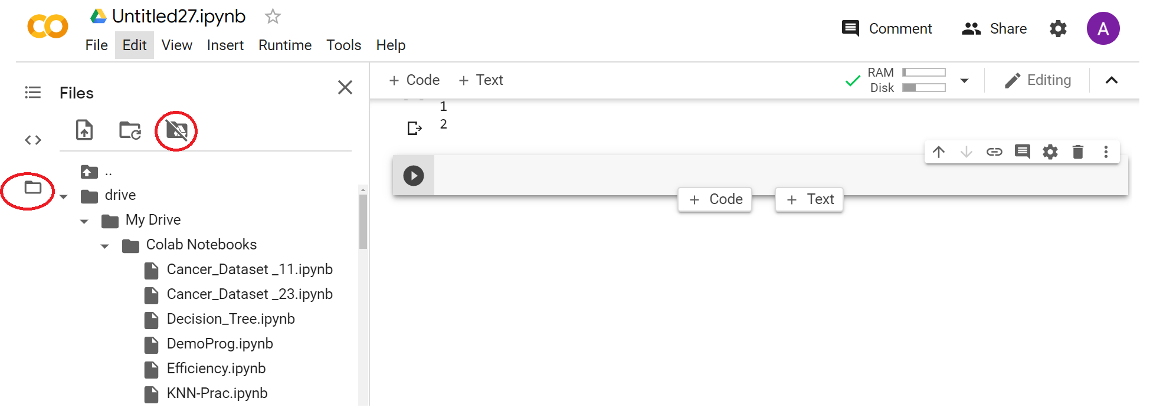

%pwd
%cd /content
%ls
%cd drive/My Drive/Colab Notebooks
%ls
import pandas as pd
df = pd.read_csv("weather_data.csv")
df

df=pd.read_excel("weather_data.xlsx","Sheet1")
df

weather_data = {
'day': ['1/1/2017','1/2/2017','1/3/2017'],
'temperature': [32,35,28],
'windspeed': [6,7,2],
'event': ['Rain', 'Sunny', 'Snow']
}
df = pd.DataFrame(weather_data)
df
weather_data = [ ('1/1/2017',32,6,'Rain'),
('1/2/2017',35,7,'Sunny'),
('1/3/2017',28,2,'Snow') ]
df = pd.DataFrame(data=weather_data,
columns=['day','temperature','windspeed','event'])
df

weather_data = [
{'day': '1/1/2017', 'temperature': 32, 'windspeed': 6, 'event': 'Rain'},
{'day': '1/2/2017', 'temperature': 35, 'windspeed': 7, 'event': 'Sunny'},
{'day': '1/3/2017', 'temperature': 28, 'windspeed': 2, 'event': 'Snow'},

]
df = pd.DataFrame(data=weather_data, columns=['day','temperature','windspeed','event'])
df

- Read Write Excel CSV File
- Upload 2 files " stock_data.csv" & "stock_data.xlsx" to your google drive "My Drive/Colab Notebooks/"
- Mount google colab to your drive

import pandas as pd

df = pd.read_csv("stock_data.csv")
df

df = pd.read_csv("stock_data.csv", skiprows=1)
df

df = pd.read_csv("stock_data.csv", header=1) # skiprows and header are kind of same
df

df = pd.read_csv("stock_data.csv", header=None, names = ["ticker","eps","revenue","people"])
df

df = pd.read_csv("stock_data.csv", nrows=2)
df

df = pd.read_csv("stock_data.csv", na_values=["n.a.", "not available"])
df

df = pd.read_csv("stock_data.csv", na_values={
'eps': ['not available'],
'revenue': [-1],
'people': ['not available','n.a.']
})
df

df.to_csv("new.csv", index=False)

df.columns

df.to_csv("new.csv",header=False)
df.to_csv("new.csv", columns=["tickers","price"], index=False)

df = pd.read_excel("stock_data.xlsx","Sheet1")
df

def convert_people_cell(cell):
if cell=="n.a.":
return 'Sam Walton'
return cell

def convert_price_cell(cell):
if cell=="n.a.":
return 50
return cell

df = pd.read_excel("stock_data.xlsx","Sheet1", converters= {
'people': convert_people_cell,
'price': convert_price_cell
})
df

df.to_excel("new.xlsx", sheet_name="stocks", index=False, startrow=2, startcol=1)

df_stocks = pd.DataFrame({
'tickers': ['GOOGL', 'WMT', 'MSFT'],
'price': [845, 65, 64 ],
'pe': [30.37, 14.26, 30.97],
'eps': [27.82, 4.61, 2.12]
})

df_weather = pd.DataFrame({
'day': ['1/1/2017','1/2/2017','1/3/2017'],
'temperature': [32,35,28],
'event': ['Rain', 'Sunny', 'Snow']
})

with pd.ExcelWriter('stocks_weather.xlsx') as writer:
df_stocks.to_excel(writer, sheet_name="stocks")
df_weather.to_excel(writer, sheet_name="weather")

- Handle Missing Data: fillna, dropna, interpolate
- Upload 2 files "weather_data_1.csv " & " weather_data_1.xls" to your google drive "My Drive/Colab Notebooks/"
- Mount google colab to your drive
%cd /content/drive/My Drive/Colab Notebooks

import pandas as pd
df = pd.read_csv("weather_data_1.csv",parse_dates=['day'])
type(df.day[0])
df

df.set_index('day',inplace=True)
df

new_df = df.fillna(0)
new_df

new_df = df.fillna({ 'temperature': 0, 'windspeed': 0, 'event': 'No Event' })
new_df

new_df = df.fillna(method="ffill")
new_df

new_df = df.fillna(method="bfill")
new_df

new_df = df.fillna(method="bfill", axis="columns")
# axis is either "index" or "columns"
new_df

new_df = df.fillna(method="ffill",limit=1)
new_df

new_df = df.interpolate()
new_df

new_df = df.interpolate(method="time")
new_df

new_df = df.dropna()
new_df

new_df = df.dropna(how='all')
new_df

new_df = df.dropna(thresh=1)
# any row/column with number of Non-NA value < thresh will be removed
new_df

dt = pd.date_range("01-01-2017","01-11-2017")
idx = pd.DatetimeIndex(dt)
df.reindex(idx)

Question: after processing missing data in each snippet, save it as a new file to your google drive

- Handle Missing Data: fillna, dropna, interpolate
- Upload 2 files "weather_data_2.csv" to your google drive "My Drive/Colab Notebooks/"
- Mount google colab to your drive
%cd /content/drive/My Drive/Colab Notebooks

import pandas as pd
import numpy as np
df = pd.read_csv("weather_data_2.csv")
df

new_df = df.replace(-99999, value=np.NaN)
new_df

new_df = df.replace(to_replace=[-99999,-88888], value=0)
new_df

new_df = df.replace({
'temperature': -99999,
'windspeed': -99999,
'event': '0'
}, np.nan)
new_df

new_df = df.replace({
-99999: np.nan,
'no event': 'Sunny',
})
new_df

# when windspeed is 6 mph, 7 mph etc. & temperature is 32 F, 28 F etc.
new_df = df.replace({'temperature': '[A-Za-z]', 'windspeed': '[a-z]'},'', regex=True)
new_df

df = pd.DataFrame({
'score': ['exceptional','average', 'good', 'poor', 'average', 'exceptional'],
'student': ['rob', 'maya', 'parthiv', 'tom', 'julian', 'erica']
})
df

df.replace(['poor', 'average', 'good', 'exceptional'], [1,2,3,4])

- Group By (Split Apply Combine)
- Upload 2 files " weather_by_cities.csv" to your google drive "My Drive/Colab Notebooks/"
- Mount google colab to your drive
%cd /content/drive/My Drive/Colab Notebooks

import pandas as pd
df = pd.read_csv("weather_by_cities.csv")
df
g = df.groupby("city")
g

for city, data in g:
print("city:",city)
print("\n")
print("data:",data)

g.get_group('mumbai')

g.max()

g.mean()

g.min()

g.describe()

g.size()
%matplotlib inline
g.plot()

def grouper(df, idx, col):
if 80 <= df[col].loc[idx] <= 90:
return '80-90'
elif 50 <= df[col].loc[idx] <= 60:
return '50-60'
else:
return 'others'

g = df.groupby(lambda x: grouper(df, x, 'temperature'))
g

for key, d in g:
print("Group by Key: {}\n".format(key))
print(d)

- Concat Dataframes
import pandas as pd

india_weather = pd.DataFrame({
"city": ["mumbai","delhi","banglore"],
"temperature": [32,45,30],
"humidity": [80, 60, 78]
})
india_weather

us_weather = pd.DataFrame({ "city": ["new york","chicago","orlando"], "temperature": [21,14,35], "humidity": [68, 65, 75] })
us_weather

df = pd.concat([india_weather, us_weather])
df

df = pd.concat([india_weather, us_weather], ignore_index=True)
df

df = pd.concat([india_weather, us_weather], keys=["india", "us"])
df
df.loc["us"]

df.loc["india"]

temperature_df = pd.DataFrame({
"city": ["mumbai","delhi","banglore"],
"temperature": [32,45,30],
}, index=[0,1,2])
temperature_df

windspeed_df = pd.DataFrame({
"city": ["delhi","mumbai"],
"windspeed": [7,12],
}, index=[1,0])
windspeed_df

df = pd.concat([temperature_df,windspeed_df],axis=1)
df

s = pd.Series(["Humid","Dry","Rain"], name="event")
s

df = pd.concat([temperature_df,s],axis=1)
df

The Laboratory Assignments:
- Retype all above statements and run it to make sure you understand each function

- Write the program to display the first 5 and last 5 rows in "Automobile_data.csv" (in file "Lab8 Pandas-III.zip")
- Replace all column values which contain ?, n.a, or NaN and empty with 0 (zero) in "Automobile_data.csv" as date preprocessing

- Print the most expansive car’s company name in Python program

- Find all cars information from Toyota company

- Write the program to display total cars for each company

*Note: push the source code to Github and submit the link in the student portal

